Scenario One, an error is created:

(1) Please log in the credentials for “1023__username,” then click on “Affiliates”  
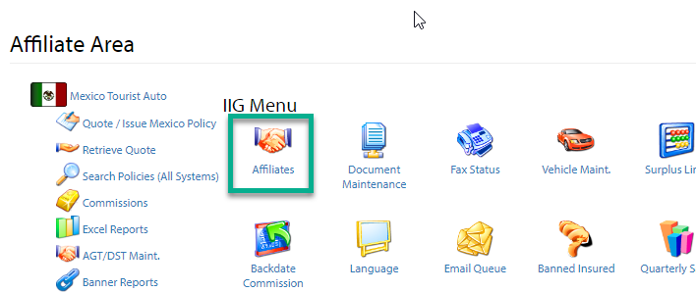

(2) Search and edit affiliate “DLLBCR.”

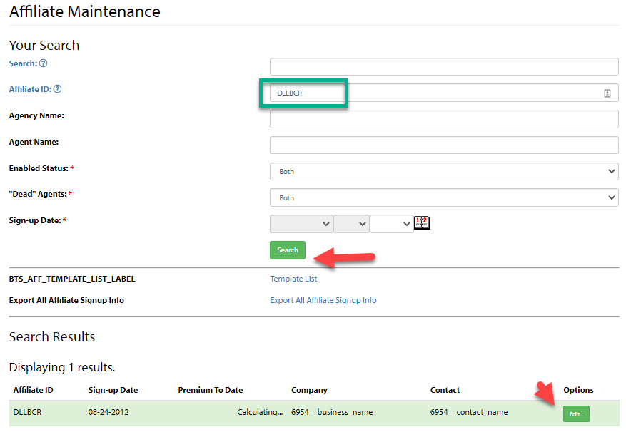

(3) Ensure affiliate “DLLBCR” and click “Manage AGT/DSTs”

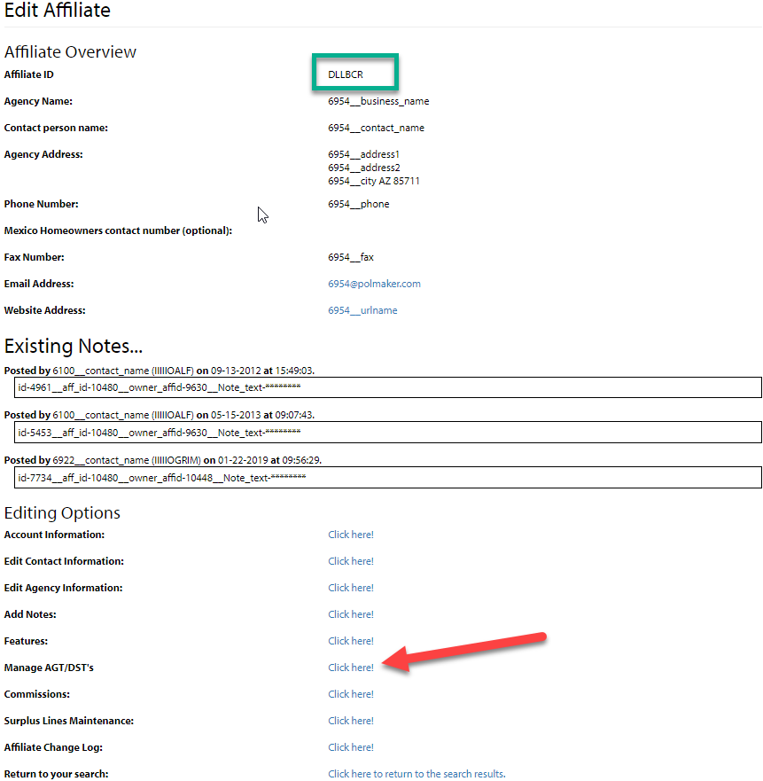

(4) Click “Add AGT/DST’s” and enter the following information:  
(Affiliate: DLLBCR)  
AGT/DST: BY7  
Description: C Insurance Group   
Agent Name: Yonvne Balwdin  
Email: [ybalwdin@cins.com](mailto:ybalwdin@cins.com)  
Phone: 5557777777  
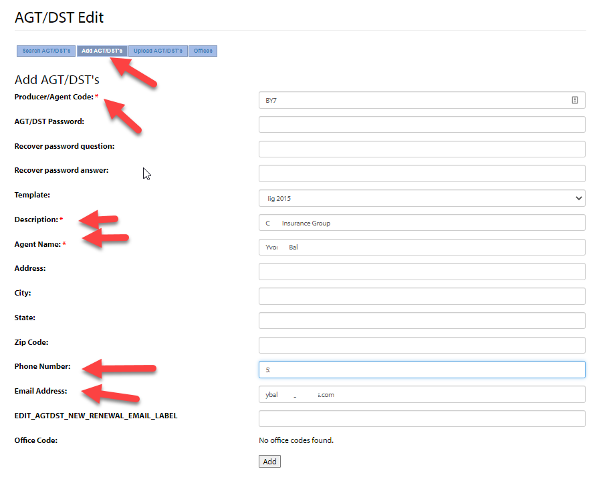

As a result upon my one and only duplication, I received an error upon hitting ‘add’ The contents of this error:  
  
Url: <https://sentry.io/organizations/mexico-insurance-online/issues/3781235868/?project=223663&query=is%3Aunresolved&referrer=issue-stream>

Error:  
Can't call method "getId" on an undefined value at /usr/src/app/htdocs/bts/dmcp/agtdst_maint/do/add_agtdst.mhtml line 19. Stack: [/usr/src/app/htdocs/bts/dmcp/agtdst_maint/do/add_agtdst.mhtml:19], [/usr/local/share/perl/5.18.2/HTML/Mason/Request.pm:948], [/.mason_data_dir/obj/1376386341/bts/dmcp/agtdst_maint/do/add_agtdst.mhtml.obj:6]  
  
File in error: <repository>/htdocs/bts/dmcp/agtdst_maint/do/add_agtdst.mhtml, line 19

I hope that you are able to replicate in your dev environment; otherwise you might need to keep adding AGTDST’s until it errors.

Scenario two: Added agtdst is placed onto the administrator’s affiliate (IIIIIOGEO, 1023) rather than the searched and added agent:

(1) Please follow the steps above, using the following information:  
Affiliate: MIOEMB  
Agent Code: TX365024  
Agent Name: Sia Pgo  
Description: S P Insurance  
Address: 190 25th St. Suite 400

City:Temple  
State: Tx  
Zip: 76574  
phone: 2222283516  
Email: srgo@tf.com

(2) Unfortunately, an error is not create. Instead, the incorrect affiliate is entered into the DB:  
SQL> select id,aff_id from agtdst_users where agtdst rlike 'TX365024';

Presents 1023 as the affiliate.  
   
It should present 1211

I hope that this is replicable in your environment.