Hi Vaibhav,

Here are more details for the MXHO Rental project:

(1) First Step Quote App “Insured Property Details”

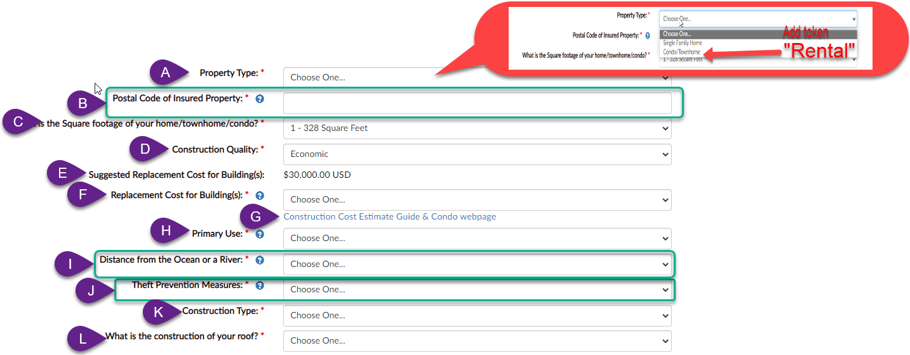

1. Property Type: Please add a new option token to be called “Rental”. It’s effect will be the hiding of options C,D,E,F,G,J,K
2. Postal Code of Insured Property: Keep this field visible and function.
3. What is the Square footage of your home/townhome/condo? : HIDE. The default value shall be “1 - 328 Square Feet”
4. Construction Quality: HIDE. The default value shall be “Economic.”
5. Suggested Replacement Cost for Building(s) and value: HIDE.
6. Replacement Cost for Building(s): HIDE. The default value shall be “$5,000.00 USD”
7. Construction Cost Estimate Guide & Condo webpage: HIDE this link.
8. Primary Use: HIDE. The default value shall be “Owner Occupied”
9. Distance from the Ocean or a River: Keep this field visible and function.
10. Theft Prevention Measures: Keep this field visible and function.
11. Construction Type: HIDE. The default value shall be “Masonry/Concrete/Steel”
12. What is the construction of your roof? HIDE. The default value shall be “Masonry/Concrete”

(2) Second Step of Quote App – Completely hide “Building Coverage”

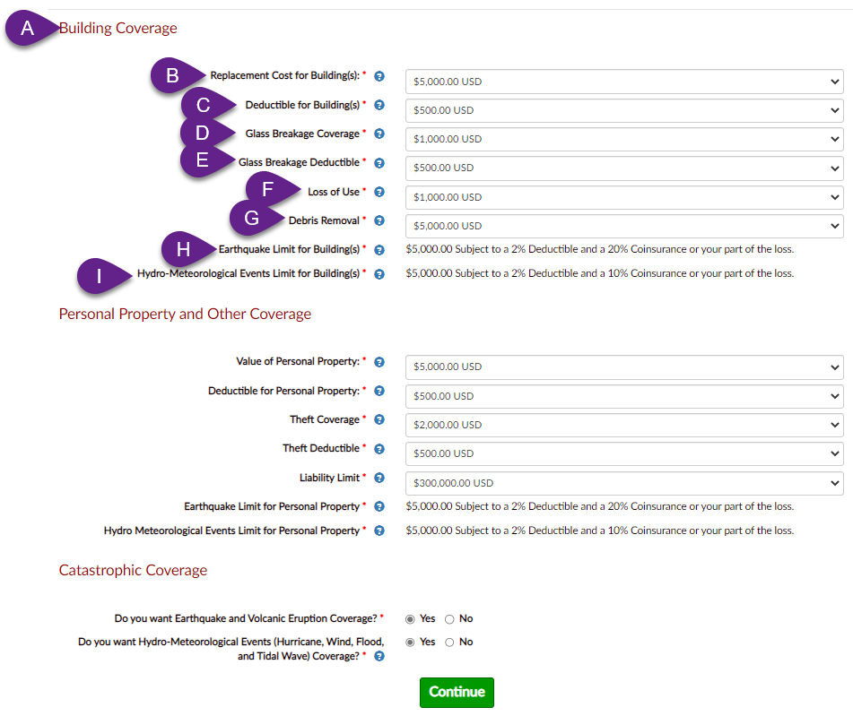

1. Building Coverage: COMPLETELY HIDE THIS SECTION
2. Replacement Cost for Building(s): HIDE. The default value shall be “$5,000.00 USD
3. Deductible for Building(s): HIDE. The default value shall be “$500.00 USD
4. Glass Breakage Coverage: HIDE. The default value shall be “$1,000.00 USD
5. Glass Breakage Deductible: HIDE. The default value shall be “$500.00 USD
6. Loss of Use: HIDE. The default value shall be “$1,000.00 USD
7. Debris Removal: HIDE. The default value shall be “$5,000.00 USD
8. Earthquake Limit for Building(s) $5,000.00 Subject to a 2% Deductible and a 20% Coinsurance or your part of the loss: HIDE
9. Hydro-Meteorological Events Limit for Building(s): $5,000.00 Subject to a 2% Deductible and a 10% Coinsurance or your part of the loss: HIDE