CAROUSEL

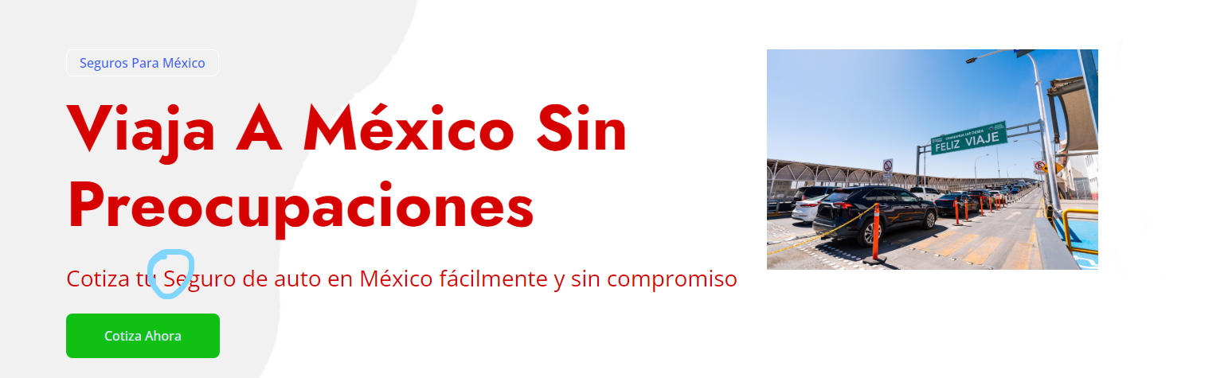

SLIDE 1:

-Cotiza tu Seguro de auto...\***Seguro**\* does not need to be capitalized

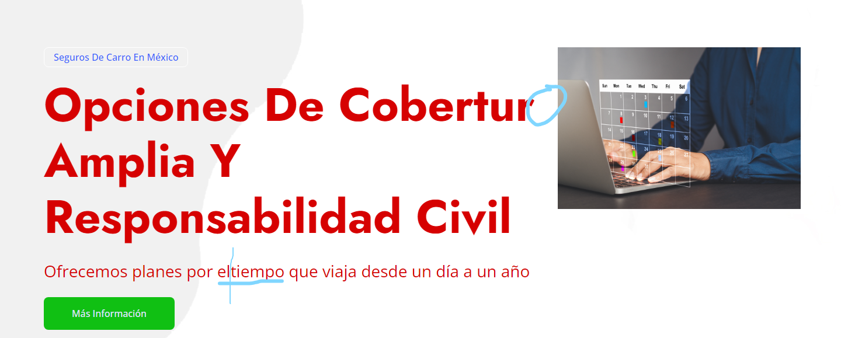

SLIDE 2:

-Opciones de cobertura **\*COBERTURA\*** IS MISSING THE '**A**' AT THE END

-Ofrecemos planes por eltiempo que viaja desde... **\*eltiempo\*** has a space between "**el**" and "**tiempo**", these are two words

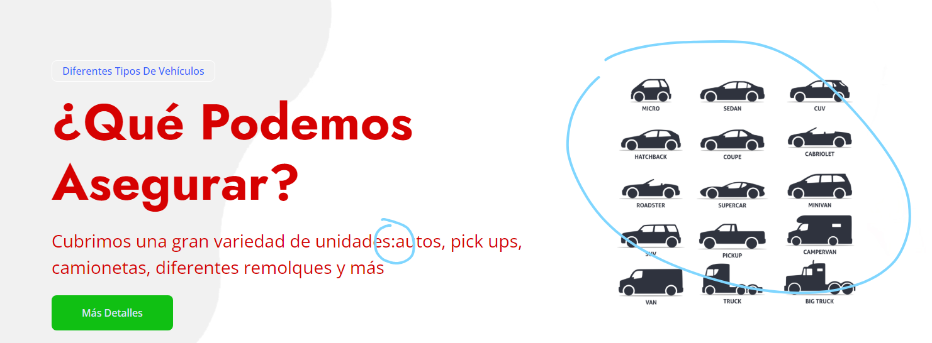

SLIDE 3: Cubrimos una gran variedad de unidades:autos, pick ups, camionetas, diferentes remolques y más

**\*insert a space between the colon after “unidades” and “autos”\***

Also, the image: we do not cover supercars, truck, or big trucks so should we change the image? As of right now WE WILL GET BACK TO YOU ON PHOTO SELECTION

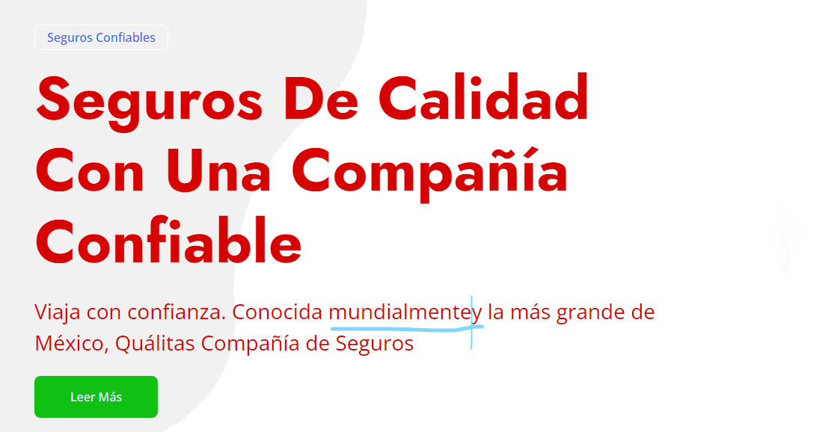SLIDE 4: Conocida mundialmentey la más grande de México,

**\*mundialmentey\*** is two words, should have a space between **"mundialmente"** and **"y"**

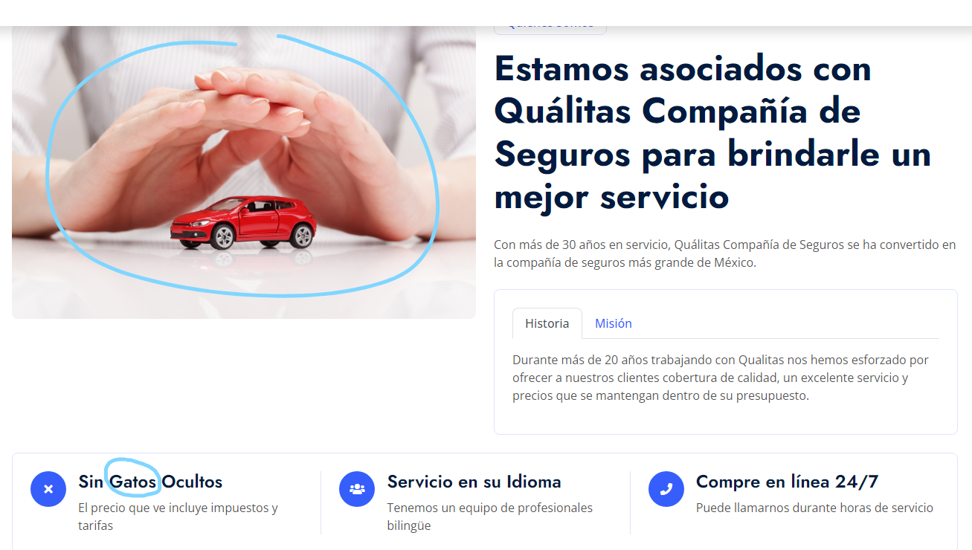

First icon with X: **\*Sin Gatos Ocultos\*** Should be **" Sin Gastos Ocultos"**. Gastos is mistyped.

**Change image to: 1075874970** ***HOWEVER THIS IMAGE MIGHT CHANGE IF WE GET QUALITAS TO SEND US AN IMAGE OF THEIR LOGO TO USE, WILL ASK DENNY***

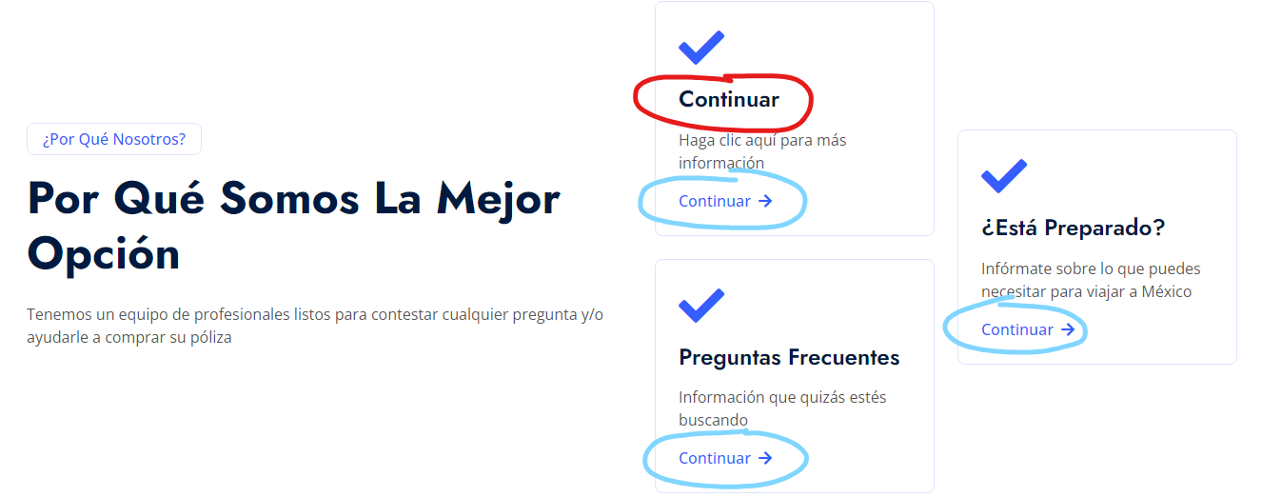

BLUE CIRCLES- These three that are circled need to be linked to the “PREGUNTAS FRECUENTES” Page that was created.

RED CIRCLE- needs to read “**Proceso De Reclamaciones”**

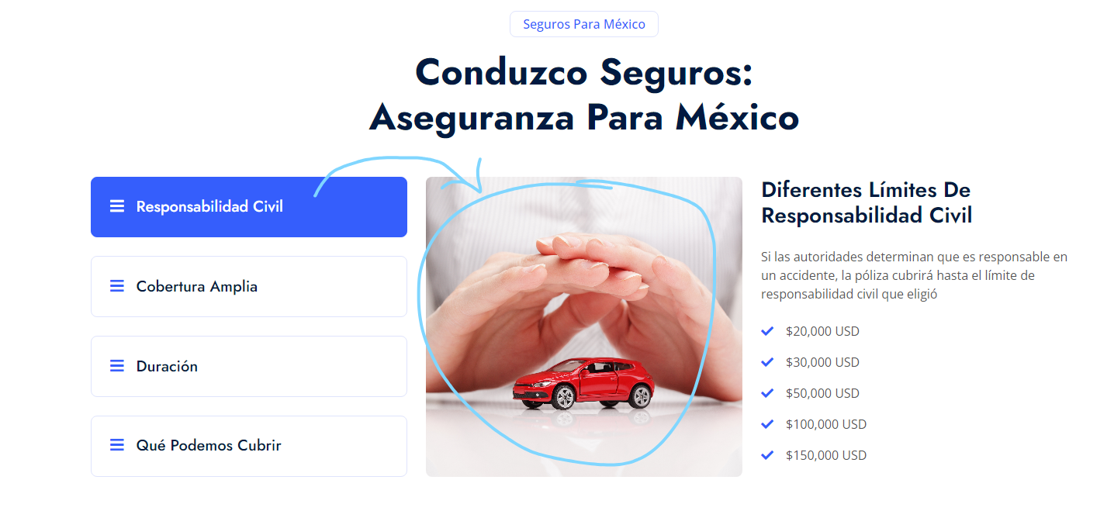

**CHANGE IMAGE TO: 951927754**

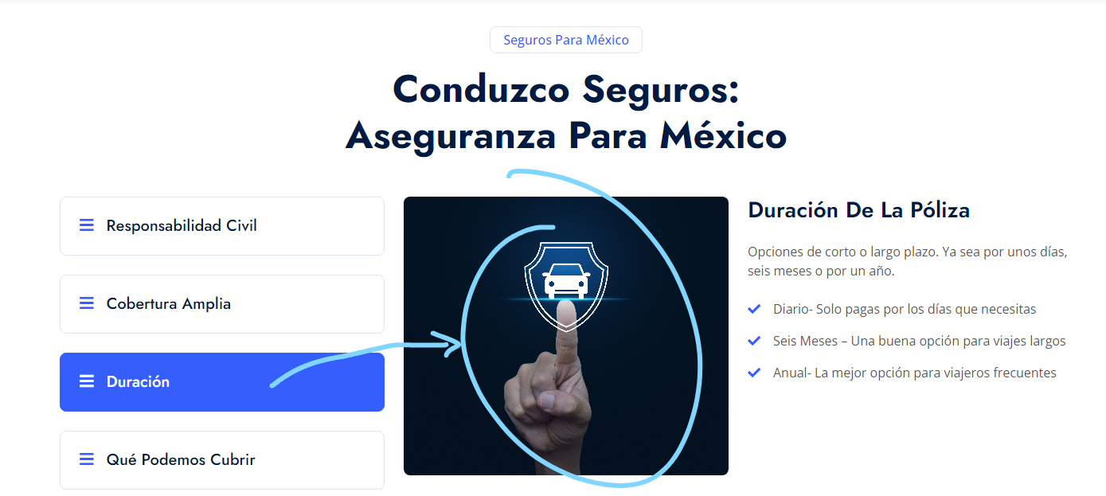

**CHANGE IMAGE TO: 1472185863**

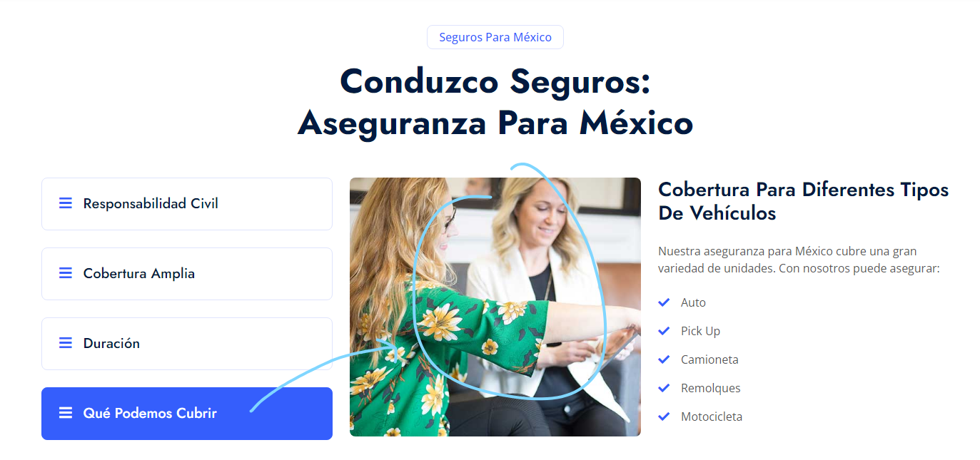

**CHANGE IMAGE TO: 1097495932**

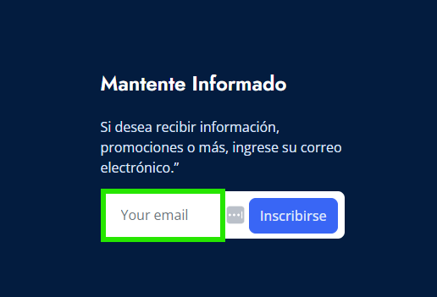

Add in Spanish in the green highlighted field: “***Su correo electrónico***”

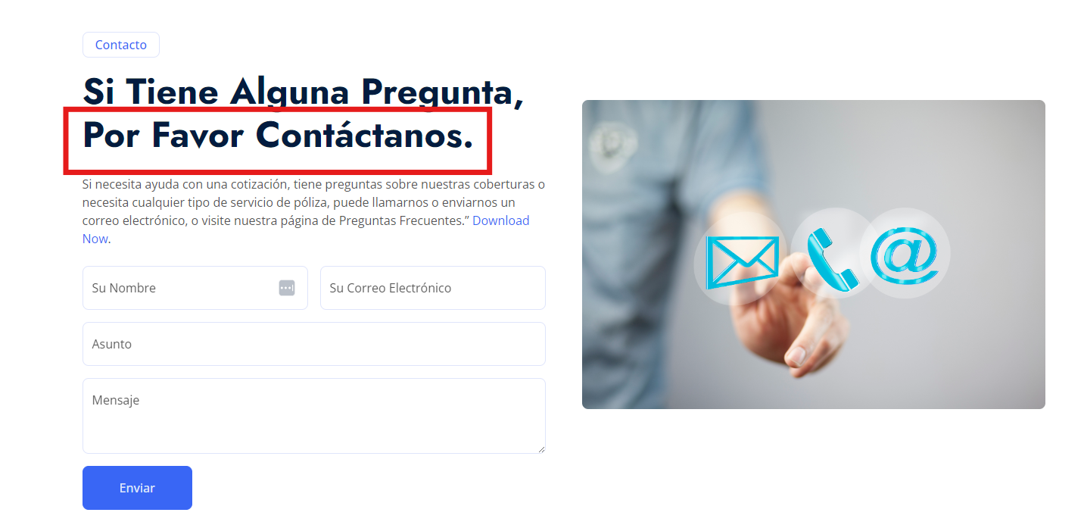Update to: **Contáctenos**